Mardi Gras 2022:
It’s My Birthday and
I Can Cry If I Want To

Regarding COVID-19
Camp Mardi Gras continues to adhere to all local and national health guidelines as directed by our health officers, as well as guidelines set out by Scouts Canada. At the time of writing, there are no restrictions in place, however, we will be using a communicable disease prevention plan to prevent the spread of similar diseases.
For further updates please check our social media accounts, website, or email info@mgcamp.com

Don your nicest party clothes and waterproof make-up for the weekend of September 23–25, 2022. Ask your registered Venturer Company, Ranger Group, Rover Crew or Link Group to join us on our journey through time. Don’t forget to bring your responsible adult (Scouter or Guider)! Let us know if you have trouble finding a group or an advisor so we can try to help you out. The birthday party is at Camp Byng, on the Sunshine Coast.

Registration:

You can register online or by mail. To pre-register for camp online, please use the form on our website mgcamp.com. As part of this form you will be expected to upload a PDF of your MyScouts/iMIS group printout showing all attendees as active/renewed. Online registration can be submitted up until Wednesday, September 21st. Please note that although online registrations may still be submitted after that date, they may not be checked. Payment can be by cheque in the mail or by cash or cheque at camp. Mailed registration forms/lists must be sent by Monday, September 12th. We even offer early registration incentives! You can email us with any registration questions at registration@mgcamp.com.

Make cheques payable to “Scouts Canada - Mardi Gras”. Cheques may be mailed in with registration forms or brought to camp.

Send your completed registration forms (last 2 pages of this document) and MyScouts/iMIS screenshots by email to registration@mgcamp.com or mail them to:

15th Capilano Rovers - Mardi Gras

c/o Amber Akerberg

4338 Pandora St.

Burnaby, BC

V5C 2B7

Transportation:

The Foot Passenger Shuttle will be meeting 4:20pm, 5:30pm and 7:50pm sailings ONLY on Friday Sept 23. Please bring $2 for ferry pick-up at the ferry terminal. Do not send your shuttle money with your registration! If you are arriving on an earlier ferry, BC Transit is available to get to Camp Byng. If you are arriving on a later ferry, please contact us and we will try to accommodate your request. We will only be taking people to the 10:50 am and 1:05 pm sailings on Sunday, if you need to leave earlier or later, please make your own arrangements.

Activities with Limited Numbers

Numbers for these activities are limited so be sure to sign up as early as possible.

These activities may be cancelled pending availability. Confirmation on whether they will run will be given at opening and be posted on our on-site schedule.

Archery:

An archery program will be run at Camp Byng’s archery range. Sign up will be at HQ on Friday night/Saturday morning on a first come first served basis with a fee of $2 per person.

Camp Law:

This is an official Scouting event – all rules, bylaws, policies, and procedures are in effect and will be enforced. Please respect the rules and the staff – it will make the weekend more enjoyable for everyone.

COVID-19 Safety:

At the time of writing, the Provincial Government and Scouts Canada do not have any restrictions in place regarding COVID-19

As policies surrounding COVID-19 may change, further updates prior to camp can be found on our social media accounts, website, or email info@mgcamp.com

Up-to-date rules regarding COVID-19 will be provided at camp

Please bring:

A current personal health form for each member, kept on their person

Your MyScouts/iMIS group list as printed from the Scouts Canada or Guides website. (See instructions on our website.)

An advisor or leader

Food, shelter, clothing, etc.… water is available onsite

There is extra emphasis on decorations and costumes! We have prizes for groups who embody the camp’s theme.

All adult members must behave in accordance with the Scouts Canada Code of Conduct at all times.

Leave behind:

Generators

Illegal drugs / alcohol/ marijuana – ZERO TOLERANCE, there will be NO warnings! (0.5% is still alcohol)

Fireworks / firecrackers / bear bangers / guns / bullhorns / megaphones / air-horns / etc. According to BP&P

No power tools or air compressors excepting handheld drills/impact drivers for site setup purposes only

Other notes:

No fires in Byng’s recycling barrels! You will be charged the cost of a barrel if you have a fire in one.

A fire permit must be obtained from HQ prior to lighting. See our website for more information.

The road is one-way only. Do not drive back down the way you came in. Please drive slowly!

Vehicles must remain on the road, even for unpacking. You cannot drive into the camping areas. If it’s got wheels, it’s a vehicle and should be on the road.

Getting to the Camp

The great thing about taking the ferry to Langdale is you only pay once! That's right, there's no charge for the return ferry! We realize that ferry is expensive, so in order to cut down your expenses, we have organized a shuttle service from the Langdale Ferry Terminal to Camp Byng for those who decide to walk-on (there is ample parking in Horseshoe Bay – check BC Ferries website for more details!). As mentioned above, the shuttle will cost $2 per person, return to help cover our shuttle costs. Please indicate on your registration form which ferry you anticipate being on so we can have enough transportation at the terminal. We will be meeting the 4:20pm, 5:30pm and 7:50pm sailings ONLY on Friday Sept 23. (Note: times may change subject to BC Ferries scheduling changes)

We ask that you not arrive before noon on Friday, as the site will not be ready for you yet.

Directions for walk-on:
- Get on Highway #1 Westbound, go all the way to Horseshoe Bay in West Vancouver down the hill and follow the signs to the passenger drop-off area – if you haven’t been recently, please be aware that the approach has changed.
- If you're not being dropped off, you can bus to the terminal using TransLink (www.translink.ca). If you want to drive, you can park your car at the BC Ferries Terminal lot.
- Get on the Langdale ferry, NOT Nanaimo or Bowen Island! It's a 40-minute ride, so enjoy the sun.
- Once at Langdale, walk to the passenger pick up area, and look for our greeter! If you're wearing your uniform (as you should be!), it'll be easy for us to identify you.
  - If you are on a sailing that doesn’t have a shuttle to camp, you can take the BCTransit public bus (Route 1) which costs $2 per person (cash only, BCTransit does not take Compass cards)
  - If you are unsure where to stop, let the bus driver know you are heading to Camp Byng, and they’ll likely let you know when you get there

Directions for drive-on are same as for walk on to get to Horseshoe Bay except… drive onto the ferry…
- Once at Langdale, drive up the hill and at the top, take a left at Marine (it's a T junction at the top of the hill).
- At North Road take a right (just follow the traffic). Follow North Road 'til the Intersection at Coast Highway (101).
- At Coast Highway (101), take a right. Continue 'til the split for Roberts Creek Lower Road (approx. 4km / 2.5mi).
- At the split for Lower Road, take a left. (Immediately after the split, there is a cemetery on the right side of the road.)

Continue along Lower Road 'till you get to Camp Byng! (Distance from the ferry terminal to Byng is 10.7 km or 6.5mi.)

Avoid going into Lower Byng (through the gates), we’re on the right (NORTH) side of the road, uphill.

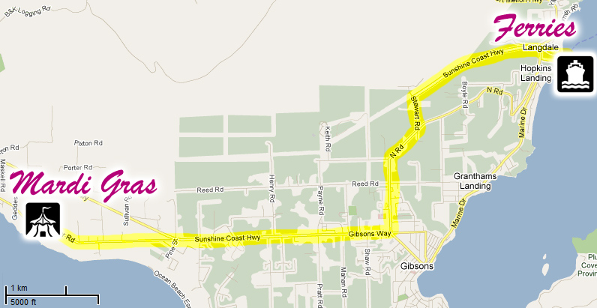

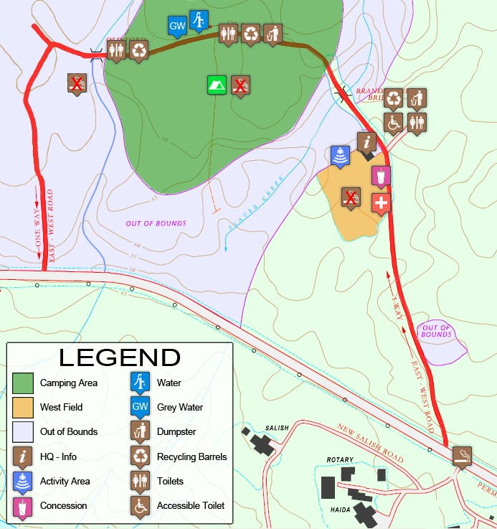
Site Map

Note: Do not camp past the second bridge

Offsite Scavenger Hunt

Bring these items with you to camp. Printouts and pictures do not count.

Points for each item. Some are worth more than others! Creativity encouraged!

- Pinata
- running makeup
- comfort food
- birthday dinner
- birthday/party hat
- candles
- midlife crisis
- balloon animal (bonus points if you make it in front of us)
- ice cream
- singing birthday card
- Goody bag
- eco friendly confetti
- River of tears
- Johnny and Judi Vinyl Record (bonus points for Leslie Gore)
- Johnny's ring
- Pin the tail on the donkey
- Birthday Present
- Birthday cake
- Clown
- Magician
- And of course… all the candy bribes!

Registration Form

We, the _____________________________________________ Crew Company Group Other __________

Of the ________________________ Council (SC) / District (GGC), ________________________ Area (GGC only)

Wish to register ________ people to attend Mardi Gras 2022: It’s My Birthday and I Can Cry If I Want To

________ people x $27 = $________ (early-bird registration – postmarked before September 1st)
What does Early-Bird registration get you? Well besides $5 how about a free shuttle ride!

________ people x $32 = $________ (late registration – postmarked after September 1st)

______ extra crests x $3 = $________ (each participant receives 1 crest with registration)
* Back crests will be for sale at the camp for the low price of $2 apiece! *
Total Enclosed: $________

* Please do not send cash in the mail! Make all cheques payable to: “Scouts Canada - Mardi Gras” *
* Don’t forget to write your GROUP NAME as it appears in MyScouts in the memo field if sending a personal cheque! *Make sure you include an iMIS/MyScouts group list printout indicating who is attending camp*

Planning on taking the shuttle? Number of people: ________ Anticipated ferry time: ________
***Please note we only plan on meeting the 4:20pm, 5:30pm and 7:50pm sailings ONLY on Friday Sept 23

Advisor’s Name ________________________________ Phone ________________________
Advisor’s Signature ______________________________________________________________
Advisor Cell Phone ______________________ Advisor Email _____________________________

Your Mailing Address (we only need one per group please!):

Name ______________________________________ Group __________________________________
Address ________________________________________________ City _________________________
Province ________________________ Postal Code ________________________
Phone ________________________ Email _____________________________

Please include an attendee list (next page) with your registration form.

If you are not pre-registering, please have this form and your MyScouts/iMIS printout with campers highlighted handy on arrival. We’ll collect it as you drive in to make for a speedier registration.

All Mardi Gras 2022 information is available on our website…
http://www.mgcamp.com
registration@mgcamp.com for registration questions / info@mgcamp.com for all other enquiries
Participant List

- Please use names as listed in MyScouts / iMIS

Name | Advisor? | MyScouts / iMIS Number | Cell Phone Number (Advisors only)
1. | Y
2. | Y
Two-scouter rule: Venturers must have at least two scouters. If you are camping with another group to fulfil the two-scouter rule, please write the group name in one of the two name fields above.
3. | Y / N
4. | Y / N
5. | Y / N
6. | Y / N
7. | Y / N
8. | Y / N
9. | Y / N
10. | Y / N
11. | Y / N
12. | Y / N
13. | Y / N
14. | Y / N
15. | Y / N

